Assignment 1

Q.1. Create application which send “HELLO” message from one activity to another with the help of submit button (Using Intent)

Activity_main.xml

<?xml version="1.0" encoding="utf-8"?>  
<RelativeLayout xmlns:android="http://schemas.android.com/apk/res/android"  
 xmlns:app="http://schemas.android.com/apk/res-auto"  
 xmlns:tools="http://schemas.android.com/tools"  
 android:layout_width="match_parent"  
 android:layout_height="match_parent"  
 tools:context=".MainActivity">  
  
 <TextView  
 android:id="@+id/activity1"  
 android:layout_width="153dp"  
 android:layout_height="wrap_content"  
 android:layout_alignParentStart="true"  
 android:layout_alignParentTop="true"  
 android:layout_alignParentEnd="true"  
 android:layout_alignParentBottom="true"  
 android:layout_marginStart="131dp"  
 android:layout_marginTop="228dp"  
 android:layout_marginEnd="126dp"  
 android:layout_marginBottom="468dp"  
 android:text="Activity 1" />  
  
  
  
 <Button  
 android:id="@+id/button"  
 android:layout_width="168dp"  
 android:layout_height="60dp"  
 android:layout_alignParentStart="true"  
 android:layout_alignParentTop="true"  
 android:layout_alignParentEnd="true"  
 android:layout_alignParentBottom="true"  
 android:layout_marginStart="126dp"  
 android:layout_marginTop="333dp"  
 android:layout_marginEnd="117dp"  
 android:layout_marginBottom="338dp"  
 android:text="Open Activity 2" />  
</RelativeLayout>

MainActivity.java

package com.example.hello_to_nextactivity;  
  
import androidx.appcompat.app.AppCompatActivity;  
  
import android.content.Intent;  
import android.os.Bundle;  
import android.view.View;  
import android.widget.Button;  
import android.widget.TextView;  
  
public class MainActivity extends AppCompatActivity {  
 private TextView activity1;  
 private Button button;  
  
 @Override  
 protected void onCreate(Bundle savedInstanceState) {  
 super.onCreate(savedInstanceState);  
 setContentView(R.layout.*activity_main*);  
  
 button = (Button) findViewById(R.id.*button*);  
 button.setOnClickListener(new View.OnClickListener() {  
 @Override  
 public void onClick(View view) {  
 openMainActivity2();  
 }  
 });  
 }  
 public void openMainActivity2(){  
 Intent intent = new Intent(this,MainActivity2.class);  
 startActivity(intent);  
 }  
}

activity_main2.xml

<?xml version="1.0" encoding="utf-8"?>  
<RelativeLayout xmlns:android="http://schemas.android.com/apk/res/android"  
 xmlns:app="http://schemas.android.com/apk/res-auto"  
 xmlns:tools="http://schemas.android.com/tools"  
 android:layout_width="match_parent"  
 android:layout_height="match_parent"  
 tools:context=".MainActivity2">  
  
 <TextView  
 android:id="@+id/activity2"  
 android:layout_width="153dp"  
 android:layout_height="wrap_content"  
 android:layout_alignParentStart="true"  
 android:layout_alignParentTop="true"  
 android:layout_alignParentEnd="true"  
 android:layout_alignParentBottom="true"  
 android:layout_marginStart="131dp"  
 android:layout_marginTop="228dp"  
 android:layout_marginEnd="126dp"  
 android:layout_marginBottom="468dp"  
 android:text="Hello world!" />  
  
</RelativeLayout>

MainActivity2.java

package com.example.hello_to_nextactivity;  
  
import androidx.appcompat.app.AppCompatActivity;  
  
import android.os.Bundle;  
  
public class MainActivity2 extends AppCompatActivity {  
  
 @Override  
 protected void onCreate(Bundle savedInstanceState) {  
 super.onCreate(savedInstanceState);  
 setContentView(R.layout.*activity_main2*);  
 }  
}

OUTPUT:

Q.2. Create application with Log-In screen after click on log-in, gives message Log-In Successful (Using Intent)

Ans:

activity_main.xml

<?xml version="1.0" encoding="utf-8"?>  
<RelativeLayout xmlns:android="http://schemas.android.com/apk/res/android"  
 xmlns:tools="http://schemas.android.com/tools"  
 android:layout_width="match_parent"  
 android:layout_height="match_parent"  
 android:paddingLeft="16dp"  
 android:paddingTop="16dp"  
 android:paddingRight="16dp"  
 android:paddingBottom="16dp"  
 tools:context=".MainActivity">  
  
 <EditText  
 android:id="@+id/editTextUsername"  
 android:layout_width="match_parent"  
 android:layout_height="wrap_content"  
 android:hint="Username"  
 android:layout_marginBottom="16dp"/>  
  
 <EditText  
 android:id="@+id/editTextPassword"  
 android:layout_width="match_parent"  
 android:layout_height="wrap_content"  
 android:hint="Password"  
 android:layout_below="@id/editTextUsername"  
 android:layout_marginBottom="16dp"  
 android:inputType="textPassword"/>  
  
 <Button  
 android:id="@+id/buttonLogin"  
 android:layout_width="match_parent"  
 android:layout_height="wrap_content"  
 android:text="Log In"  
 android:layout_below="@id/editTextPassword"  
 android:onClick="login"/>  
  
</RelativeLayout>

MainActivity.java

package com.example.q2;  
  
import androidx.appcompat.app.AppCompatActivity;  
  
import android.content.Intent;  
import android.os.Bundle;  
import android.view.View;  
import android.widget.Button;  
import android.widget.EditText;  
import android.widget.TextView;  
import android.widget.Toast;  
  
public class MainActivity extends AppCompatActivity {  
 private EditText editTextUsername, editTextPassword;  
 private Button button;  
  
 @Override  
 protected void onCreate(Bundle savedInstanceState) {  
 super.onCreate(savedInstanceState);  
 setContentView(R.layout.*activity_main*);  
  
 editTextUsername = findViewById(R.id.*editTextUsername*);  
 editTextPassword = findViewById(R.id.*editTextPassword*);  
 }  
 public void login(View view){  
 String username = editTextUsername.getText().toString();  
 String password = editTextPassword.getText().toString();  
  
 if(username.equals("user") && password.equals("password"))  
 {  
 Intent intent = new Intent(this,SuccessActivity.class);  
 startActivity(intent);  
 }  
 else if (username.isEmpty() && password.isEmpty() )  
 {  
 Toast.*makeText*(this, "Invalid Credentials", Toast.*LENGTH_SHORT*).show();  
 }  
 else {  
 Toast.*makeText*(this, "Login Successfully", Toast.*LENGTH_SHORT*).show();  
 }  
 }  
}

activity_success.xml

<?xml version="1.0" encoding="utf-8"?>  
<androidx.constraintlayout.widget.ConstraintLayout xmlns:android="http://schemas.android.com/apk/res/android"  
 xmlns:app="http://schemas.android.com/apk/res-auto"  
 xmlns:tools="http://schemas.android.com/tools"  
 android:layout_width="match_parent"  
 android:layout_height="match_parent"  
 tools:context=".SuccessActivity">  
  
</androidx.constraintlayout.widget.ConstraintLayout>

SuccessActivity.java

package com.example.q2;  
  
import androidx.appcompat.app.AppCompatActivity;  
  
import android.os.Bundle;  
  
public class SuccessActivity extends AppCompatActivity {  
  
 @Override  
 protected void onCreate(Bundle savedInstanceState) {  
 super.onCreate(savedInstanceState);  
 setContentView(R.layout.*activity_success*);  
 }  
}

OUTPUT :

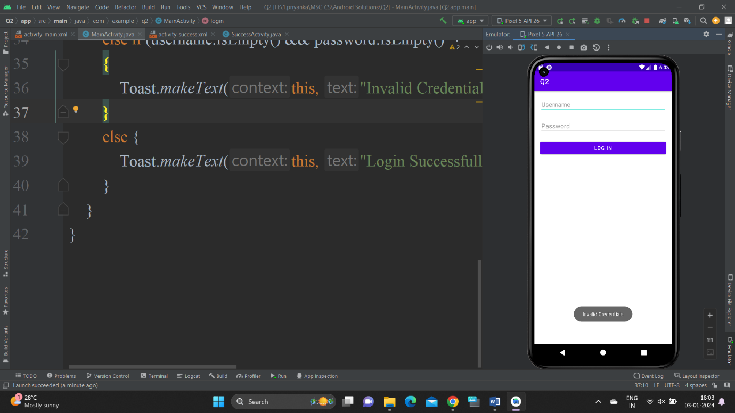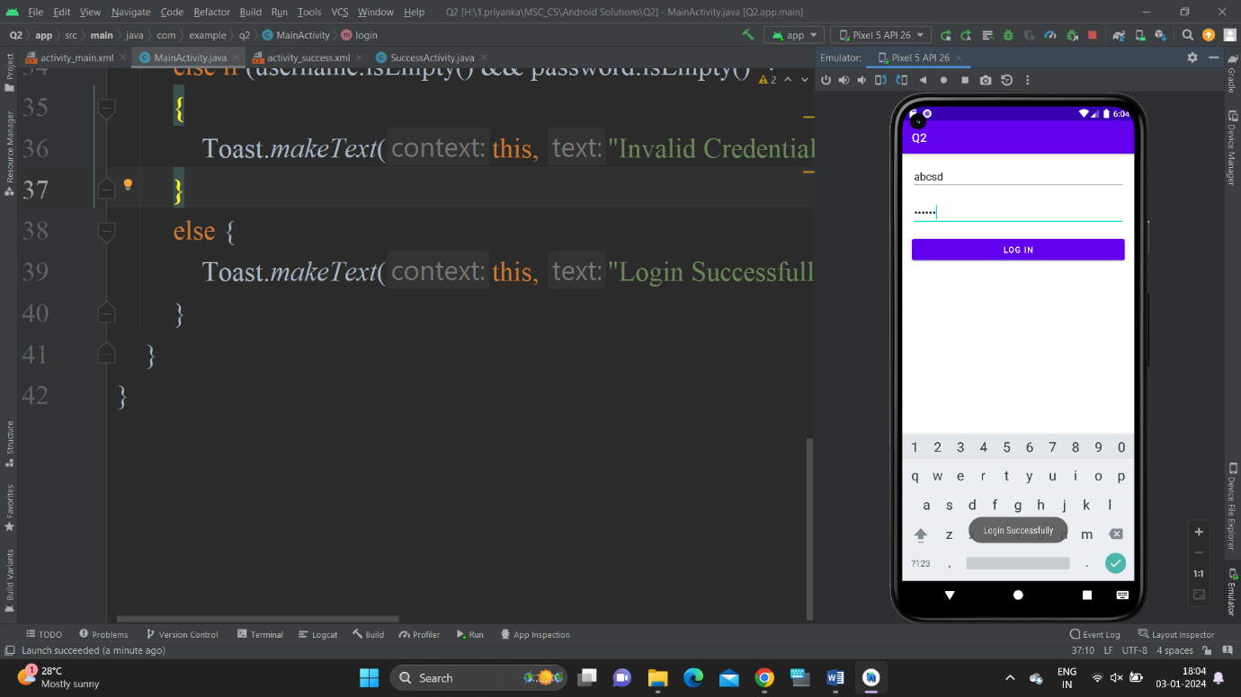

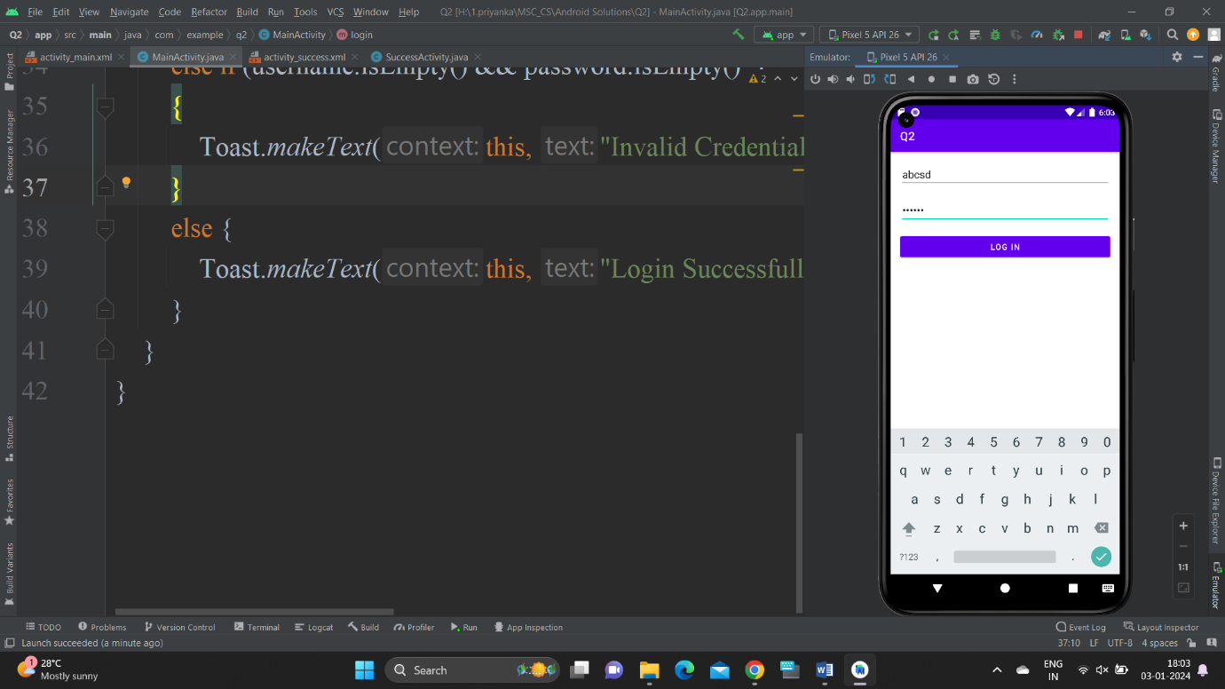

Q.3. Create the first activity to accept information like student First name, Middle Name(Optional) Last name, Date Of Birth, Address, Email address and display all information on second activity when user clicks on submit button.

Ans :

activity_main.xml

<!-- res/layout/activity_main.xml -->  
<LinearLayout xmlns:android="http://schemas.android.com/apk/res/android"  
 xmlns:tools="http://schemas.android.com/tools"  
 android:layout_width="match_parent"  
 android:layout_height="match_parent"  
 android:background="#D588E3"  
 android:orientation="vertical"  
 android:padding="16dp"  
 tools:context=".MainActivity">  
  
 <EditText  
 android:id="@+id/editTextFirstName"  
 android:layout_width="match_parent"  
 android:layout_height="wrap_content"  
 android:hint="First Name" />  
  
 <EditText  
 android:id="@+id/editTextMiddleName"  
 android:layout_width="match_parent"  
 android:layout_height="wrap_content"  
 android:hint="Middle Name (Optional)" />  
  
 <EditText  
 android:id="@+id/editTextLastName"  
 android:layout_width="match_parent"  
 android:layout_height="wrap_content"  
 android:hint="Last Name" />  
  
 <EditText  
 android:id="@+id/editTextDOB"  
 android:layout_width="match_parent"  
 android:layout_height="wrap_content"  
 android:hint="Date of Birth" />  
  
 <EditText  
 android:id="@+id/editTextAddress"  
 android:layout_width="match_parent"  
 android:layout_height="wrap_content"  
 android:hint="Address" />  
  
 <EditText  
 android:id="@+id/editTextEmail"  
 android:layout_width="match_parent"  
 android:layout_height="wrap_content"  
 android:hint="Email Address" />  
  
 <Button  
 android:id="@+id/buttonSubmit"  
 android:layout_width="wrap_content"  
 android:layout_height="wrap_content"  
 android:text="Submit"  
 />  
</LinearLayout>

MainActivity.java

package com.example.q3;  
  
import androidx.appcompat.app.AppCompatActivity;  
  
import android.content.Intent;  
import android.os.Bundle;  
import android.view.View;  
import android.widget.Button;  
import android.widget.EditText;  
  
public class MainActivity extends AppCompatActivity {  
 private EditText firstNameEditText, middleNameEditText, lastNameEditText;  
 private EditText dobEditText, addressEditText, emailEditText;  
 private Button submitButton;  
  
 @Override  
 protected void onCreate(Bundle savedInstanceState) {  
 super.onCreate(savedInstanceState);  
 setContentView(R.layout.*activity_main*);  
  
 firstNameEditText = findViewById(R.id.*editTextFirstName*);  
 middleNameEditText = findViewById(R.id.*editTextMiddleName*);  
 lastNameEditText = findViewById(R.id.*editTextLastName*);  
 dobEditText = findViewById(R.id.*editTextDOB*);  
 addressEditText = findViewById(R.id.*editTextAddress*);  
 emailEditText = findViewById(R.id.*editTextEmail*);  
 submitButton = findViewById(R.id.*buttonSubmit*);  
  
 submitButton.setOnClickListener(new View.OnClickListener() {  
 @Override  
 public void onClick(View view) {  
 String firstName = firstNameEditText.getText().toString();  
 String middleName = middleNameEditText.getText().toString();  
 String lastName = lastNameEditText.getText().toString();  
 String dob = dobEditText.getText().toString();  
 String address = addressEditText.getText().toString();  
 String email = emailEditText.getText().toString();  
  
 Intent intent = new Intent(MainActivity.this,DisplayActivity2.class);  
  
 intent.putExtra("FIRST_NAME", firstName);  
 intent.putExtra("MIDDLE_NAME", middleName);  
 intent.putExtra("LAST_NAME", lastName);  
 intent.putExtra("DOB", dob);  
 intent.putExtra("ADDRESS", address);  
 intent.putExtra("EMAIL", email);  
  
 startActivity(intent);  
  
 }  
 });  
  
 }  
}

activity_display2.xml

<!-- res/layout/activity_display.xml -->  
<LinearLayout  
 xmlns:android="http://schemas.android.com/apk/res/android"  
 android:layout_width="match_parent"  
 android:layout_height="match_parent"  
 android:orientation="vertical"  
 android:padding="16dp">  
  
 <TextView  
 android:id="@+id/textViewName"  
 android:layout_width="wrap_content"  
 android:layout_height="wrap_content"  
 android:text="Name: "/>  
  
 <TextView  
 android:id="@+id/textViewDOB"  
 android:layout_width="wrap_content"  
 android:layout_height="wrap_content"  
 android:text="Date of Birth: "/>  
  
 <TextView  
 android:id="@+id/textViewAddress"  
 android:layout_width="wrap_content"  
 android:layout_height="wrap_content"  
 android:text="Address: "/>  
  
 <TextView  
 android:id="@+id/textViewEmail"  
 android:layout_width="wrap_content"  
 android:layout_height="wrap_content"  
 android:text="Email: "/>  
</LinearLayout>

DisplayActivity2.java

package com.example.q3;  
  
import androidx.appcompat.app.AppCompatActivity;  
  
import android.content.Intent;  
import android.os.Bundle;  
import android.widget.TextView;  
  
public class DisplayActivity2 extends AppCompatActivity {  
  
 @Override  
 protected void onCreate(Bundle savedInstanceState) {  
 super.onCreate(savedInstanceState);  
 setContentView(R.layout.*activity_display2*);  
  
 Intent intent = getIntent();  
 String firstName = intent.getStringExtra("FIRST_NAME");  
 String middleName = intent.getStringExtra("MIDDLE_NAME");  
 String lastName = intent.getStringExtra("LAST_NAME");  
 String dob = intent.getStringExtra("DOB");  
 String address = intent.getStringExtra("ADDRESS");  
 String email = intent.getStringExtra("EMAIL");  
  
 TextView textViewName = findViewById(R.id.*textViewName*);  
 textViewName.setText("Name: " + firstName + " " + (middleName.isEmpty() ? "" : middleName + " ") + lastName);  
  
 TextView textViewDOB = findViewById(R.id.*textViewDOB*);  
 textViewDOB.setText("Date of Birth: " + dob);  
  
 TextView textViewAddress = findViewById(R.id.*textViewAddress*);  
 textViewAddress.setText("Address: " + address);  
  
 TextView textViewEmail = findViewById(R.id.*textViewEmail*);  
 textViewEmail.setText("Email: " + email);  
  
 }  
}

OUTPUT :

